Lab 2

Test and measurements

**Question 1:**

1. Item 10 have the highest item difficulty (0,529). Item 5 have the lowest item difficulty (-1,63).  
     
   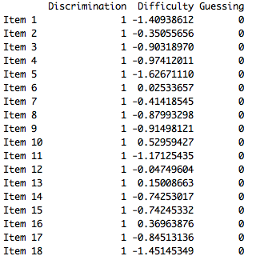
2. -1.62 ±1.96 * 0.132 =  
   -1,88 to -1.36.

We can say with 95% confidence that the item difficulty for the easiest item (item 5), is between -1.88 to -1.36.

1. 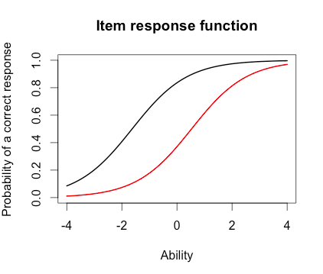
2. For a person with ability 0, she has a probability of 0.2 of getting item 10 correct (red line) and 0.8 of getting item 5 correct (black line).
3. The person who did the best was numbered 49 and the score was 3.99

The person who did the worst was numbered 393 and the score was -3.99

1. 3.99 ±1.96 * 2.20 = -0.32 to 8.30  
   With 95% confidence we can say that the student that did the best had an ability estimate between -0.32 to 8.30.

**Question 2:**

1. Items selected: 1, 10 and 15
2. 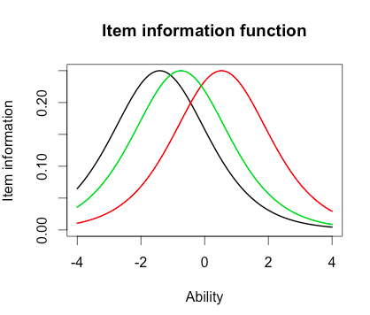
3. Same: All of the items had the same maximum Item Information, 0.25.

Different: The item difficulty is different for all of the items.

1. 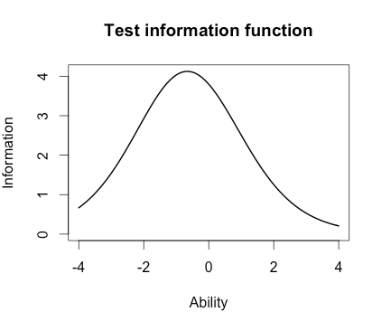
2. Around -0.8

**Question 3:**

1. Highest discrimination: Item 8 has 2.8  
   Lowest discrimination: Item 12 has 0.332
2. No there were different items easiest and hardest in the Rash model (items 5 and 10, see question 1a)). In 2-PL item 1 was the easiest and item 10 was the hardest.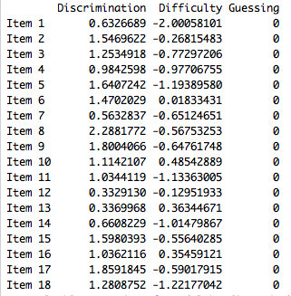
3. The correlation between the ability estimates on the Rasch model and the 2-PL is r = 0.97, that is a strong correlation.   
   Since the correlation is nearly perfect (r = 1.00) we would estimate that the person abilities are very similar using the two models.
4. 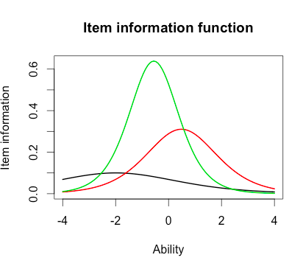
5. How do the 2-PL item information functions from these items differ from their Rasch item information functions?

The items information is very different between items. The black line (Item 1) for example does not discriminate well between students compared to the two other lines. The green line (item 15) discriminate the best between students.  
The 2-PL items information differs from the Rash model items information. Because the 2-PL model takes discriminator into account and therefore the items information differ. In the Rash model all of the items have the same item information, because there is no discriminator in the model.

**Output:**

Discrimination Difficulty Guessing

Item 1 1 -1.40938612 0

Item 2 1 -0.35055656 0

Item 3 1 -0.90318970 0

Item 4 1 -0.97412011 0

Item 5 1 -1.62671110 0

Item 6 1 0.02533657 0

Item 7 1 -0.41418545 0

Item 8 1 -0.87993298 0

Item 9 1 -0.91498121 0

Item 10 1 0.52959427 0

Item 11 1 -1.17125435 0

Item 12 1 -0.04749604 0

Item 13 1 0.15008663 0

Item 14 1 -0.74253017 0

Item 15 1 -0.74245332 0

Item 16 1 0.36963876 0

Item 17 1 -0.84513136 0

Item 18 1 -1.45145349 0

> est_se <- rasch_model$se

> colnames(est_se) <- c("Discrimination SE", "Difficulty SE", "Guessing SE")

> rownames(est_se) <- paste("Item", 1:18)

> est_se

Discrimination SE Difficulty SE Guessing SE

Item 1 NA 0.1267448 0

Item 2 NA 0.1128011 0

Item 3 NA 0.1178581 0

Item 4 NA 0.1188426 0

Item 5 NA 0.1320051 0

Item 6 NA 0.1118476 0

Item 7 NA 0.1131572 0

Item 8 NA 0.1175527 0

Item 9 NA 0.1180162 0

Item 10 NA 0.1136598 0

Item 11 NA 0.1220123 0

Item 12 NA 0.1118797 0

Item 13 NA 0.1119630 0

Item 14 NA 0.1159197 0

Item 15 NA 0.1159189 0

Item 16 NA 0.1126941 0

Item 17 NA 0.1171115 0

Item 18 NA 0.1276902 0

> plot(irf(est_params[c(5,10),]), co = NA)

> -1.62+1.96*0.132

[1] -1.36128

> est_abl <- as.data.frame(mlebme(Scored, ip = est_params))

> min(est_abl$est)

[1] -3.999947

> max(est_abl$est)

[1] 3.999921

> which.min(est_abl$est)

[1] 393

> which.max(est_abl$est)

[1] 49

> est_abl[49,393]

NULL

> est_abl[49,]

est sem n

49 3.999921 2.204373 18

> est_abl[393,]

est sem n

393 -3.999947 1.225286 18

> 3.99-1.96*2.2

[1] -0.322

> plot(iif(est_params[c(1,10,15),]), co = NA)

> plot(tif(est_params))

> twopl_model <- est(Scored, model="2PL", engine="ltm")

> twopl_params <- twopl_model$est

> colnames(twopl_params) <- c("Discrimination", "Difficulty", "Guessing")

> rownames(twopl_params) <- paste("Item", 1:18)

> twopl_params

Discrimination Difficulty Guessing

Item 1 0.6326689 -2.00058101 0

Item 2 1.5469622 -0.26815483 0

Item 3 1.2534918 -0.77297206 0

Item 4 0.9842598 -0.97706755 0

Item 5 1.6407242 -1.19389580 0

Item 6 1.4702029 0.01833431 0

Item 7 0.5632837 -0.65124651 0

Item 8 2.2881772 -0.56753253 0

Item 9 1.8004066 -0.64761748 0

Item 10 1.1142107 0.48542889 0

Item 11 1.0344119 -1.13363005 0

Item 12 0.3329130 -0.12951933 0

Item 13 0.3369968 0.36344671 0

Item 14 0.6608229 -1.01479867 0

Item 15 1.5980393 -0.55640285 0

Item 16 1.0362116 0.35459121 0

Item 17 1.8591845 -0.59017915 0

Item 18 1.2808752 -1.22177042 0

> twopl_abl <- as.data.frame(mlebme(Scored, ip = twopl_params))

> cor(twopl_abl$est,est_abl$est)

[1] 0.9709497